Classification of the Dates (Ajwa or Medjool) using Deep Neural Network (DNN) and TensorFlow Lite on ESP32

Submitted by
Chudarathnamani L
1RVU23LCSE003
School of Computer Science
RV University

Submitted to
Prof. Veena S
Professor
School of Computer Science
RV University

Submission date [20-11-2024]

- Abstract
This project focuses on developing a Deep Neural Network (DNN) model for classifying dates (Ajwa or Medjool) based on various features such as size, color, and weight. The model is trained using TensorFlow, converted to TensorFlow Lite format for deployment on an ESP32 microcontroller. The primary objective is to demonstrate how edge computing with TensorFlow Lite can enable efficient inference on low-resource devices, allowing real-time date classification with minimal latency and resource consumption.

- Introduction

Project Background and Relevance: Overview of IoT and Edge Computing
The Internet of Things (IoT) refers to the network of physical devices embedded with sensors, software, and other technologies to exchange data and interact with the environment. IoT is widely used in applications ranging from smart homes to healthcare systems. It enables devices to gather data and make intelligent decisions without the need for continuous human intervention.
Edge Computing is a paradigm that processes data closer to its source, rather than sending it to centralized cloud servers. This reduces latency, conserves bandwidth, and enhances system performance, making it especially useful for real-time applications where immediate decision-making is necessary. By performing computations on edge devices, such as IoT sensors or microcontrollers, edge computing offers fast, localized data processing, improving efficiency and minimizing network traffic.
In this project, the integration of IoT and Edge Computing is demonstrated by using an embedded device, the ESP32, to classify dates into two categories: Ajwa and Medjool. By combining deep learning with edge processing, the model’s inference is conducted directly on the ESP32 without needing a cloud server, showcasing the power of machine learning on resource-constrained devices.

Objectives:
The main goal of this project is to develop a Deep Neural Network (DNN) model for classifying dates based on their characteristics, such as size, weight, and color. This model is trained on a dataset and then converted into the TensorFlow Lite (TFLite) format, optimized for deployment on embedded systems. The ESP32 microcontroller is used to run the model locally, performing real-time classification without cloud dependency. This project aims to demonstrate the feasibility of running machine learning models on low-power, edge devices, offering practical applications in areas like agriculture, food industry, and more, where quick, localized decision-making is crucial.

- System Overview

System Architecture: Outline of Data Flow and Key Components
- Data Collection: The system begins by collecting input data such as size, weight, color, and texture of dates (Ajwa or Medjool). These data points are gathered using sensors or manually fed into the system.
- Data Preprocessing: The collected data is preprocessed to standardize or scale the values, ensuring that the model can efficiently process and classify the inputs. This includes normalization or feature encoding, such as converting color into numeric values.
- Model Training: A Deep Neural Network (DNN) model is trained on a dataset that includes labeled examples of both Ajwa and Medjool dates. The model learns to identify patterns and relationships between the input features and the corresponding labels (Ajwa or Medjool).
- Model Conversion to TensorFlow Lite (TFLite): After training, the DNN model is converted to TensorFlow Lite format. This process reduces the model’s size and makes it suitable for deployment on edge devices like the ESP32, which has limited computational power.
- ESP32 Deployment: The TFLite model is uploaded onto the ESP32 microcontroller, which processes incoming data (new date samples) locally. The ESP32 runs the model to predict whether a date is Ajwa or Medjool based on the features it receives.
- Inference and Output: After the model performs inference, the predicted classification (Ajwa or Medjool) is displayed on the ESP32's serial monitor or sent to an external display, giving the user immediate feedback. The system operates in real-time, offering fast and efficient predictions without relying on cloud-based resources.
- Details of the Dataset:

The dataset used in this project is focused on classifying dates, specifically Ajwa and Medjool varieties, based on various physical attributes. The problem the model solves is determining the type of date based on features such as size, weight, color, and texture. This classification can be valuable for agriculture, retail, and quality control purposes.

Input Categories:

Size: The dimension of the date, usually measured in millimeters (e.g., length, width).
Weight: The mass of the date, typically measured in grams.
Color: The color of the date, encoded into numeric values (e.g., 'Black', 'Brown').
Texture: The surface texture, which can indicate whether the date is soft, firm, or dry.
Outputs: The model outputs a classification label, identifying whether the date is Ajwa or Medjool.

This dataset allows the deep neural network model to learn correlations between these input features and predict the correct type of date, making it a valuable tool for automating date classification tasks.

- Model Design:

The deep neural network (DNN) model for date classification is designed with several layers and nodes to process the input data and make accurate predictions. Below is a breakdown of the model architecture:

Model Architecture:
- Input Layer:
  - Nodes: 6 (representing the 6 input features: Size, Weight, Color, and Texture encoded numerically)
  - Activation Function: None (raw input values)
- Hidden Layers:
  - First Hidden Layer:
    - Nodes: 64
    - Activation Function: ReLU (Rectified Linear Unit)
    - This layer learns complex relationships and patterns from the input data.
  - Second Hidden Layer:
    - Nodes: 32
    - Activation Function: ReLU
    - This layer further refines the model's understanding by processing more abstract features.
- Output Layer:
  - Nodes: 1
  - Activation Function: Sigmoid
    - The sigmoid function ensures the output is in a binary format, with values close to 0 or 1. The output represents the probability of the date being one of the two types (Ajwa or Medjool).

Diagram of Model Architecture:

This architecture helps the model efficiently classify dates based on the provided features. The hidden layers help in learning complex patterns in the data, while the output layer gives the final classification. The use of ReLU helps with faster convergence and preventing vanishing gradients, and the sigmoid activation at the output ensures the model outputs probabilities between 0 and 1, which are suitable for binary classification.

- Requirements
  - Hardware: The project uses the ESP32 microcontroller, which provides Wi-Fi and Bluetooth capabilities to enable edge computing and run the model locally for inference.
  - Software: The main software components include Python libraries such as TensorFlow for training the DNN, and TensorFlow Lite for model conversion to a lightweight format suitable for the ESP32.
  - IDE: Development is done using an IDE like VS Code or Arduino IDE for coding and uploading the model to the ESP32.
  - Protocols: The project may use protocols like MQTT for efficient communication between the ESP32 and external systems, enabling real-time data exchange.

- Methodology
Setup: Hardware and Software Configuration
- Hardware: The ESP32 is used for running the machine learning model and making predictions on the edge, with Wi-Fi and Bluetooth capabilities.
- Software: The model is trained using Python and TensorFlow. After training, it's converted to TensorFlow Lite format for deployment on the ESP32. The ESP32 code loads the model and performs inference with input data.
Code Summary: Key Functions
- Model Training: The Python code loads the dataset, preprocesses the data, and trains a Deep Neural Network (DNN) model using TensorFlow.
- Model Conversion: The trained model is converted to TensorFlow Lite (.tflite) format to optimize it for ESP32.
- ESP32 Deployment: The ESP32 code loads the .tflite model and makes predictions based on input data (e.g., date features), displaying the result on the Serial Monitor.

- Implementation and Testing:
Step-by-Step Process
      - Python Code Analysis (DNN Model Training and TensorFlow Lite Conversion)
- Dataset: The dataset used in this project is related to Ajwa or Medjool dates. The dataset consists of features like date length, diameter, weight, pit length, calories, and color. These are numerical values used for classification.
- Data Preprocessing:
  - Normalization/Standardization: The features are scaled using MinMaxScaler from sklearn, ensuring that each input feature is in the same range and suitable for feeding into the DNN.
  - Label Encoding: The color data is encoded numerically (e.g., "Black" is assigned a numeric value).
- Model Architecture: A Deep Neural Network (DNN) is defined with the following layers:
  - Input layer: Corresponding to the six features (date length, diameter, weight, pit length, calories, color).
  - Hidden layers: Multiple dense layers with activation functions like ReLU to introduce non-linearity.
  - Output layer: A single neuron representing the prediction (class 0 or 1).
The model uses Adam optimizer for efficient training and binary cross-entropy loss since the task is a binary classification problem.
- Model Training: The model is trained on the dataset with a batch size of 32 for 10 epochs. The validation data is used to track the performance during training, ensuring that the model doesn't overfit.
- Model Conversion to TensorFlow Lite: After training, the model is converted to the TensorFlow Lite format (.tflite) using the TFLiteConverter. This conversion allows the model to be run efficiently on edge devices like the ESP32.
The model is then saved as dnn_date_classifier.tflite and is ready for deployment on the ESP32.
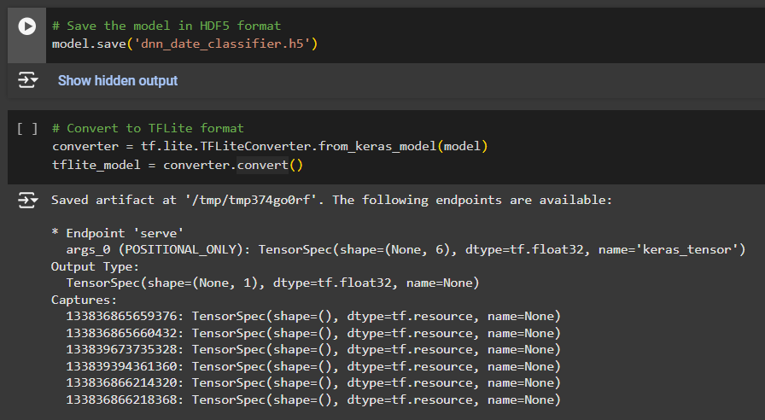

2. ESP32 Code and Deployment Process
The next step is to port the trained TensorFlow Lite model to the ESP32. The provided ESP32 code loads the .tflite model and performs inference on the device. Below is a breakdown of the key steps in the ESP32 code, explaining the process:
Step-by-Step Breakdown of the ESP32 Code:
- Libraries and Setup:
- The necessary libraries for TensorFlow Lite for Microcontrollers (TensorFlowLite_ESP32.h) are included to enable model deployment on the ESP32.
- The model data (dnn_date_classifier_tflite) is included as a header file. This is the model that was previously converted to .tflite format.
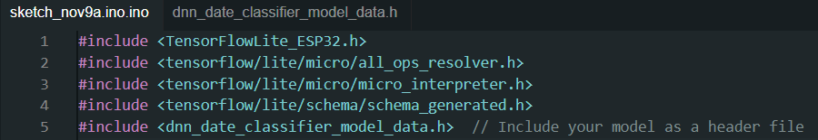

- Memory Allocation:
- A memory buffer (tensor arena) is created to allocate memory for the input and output tensors required for model inference. The buffer size is defined based on the model's memory requirements (10 * 1024).

- Custom Error Handling:
- A CustomErrorReporter class is defined to handle error reporting during the inference process. If any issue occurs while loading or executing the model, the error message will be displayed via the serial monitor.
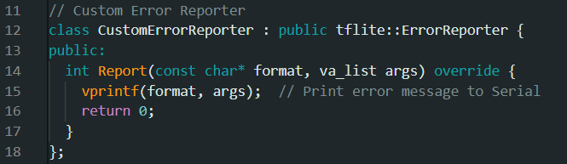

- Model Loading and Tensor Allocation:
- The TensorFlow Lite model is loaded using tflite::GetModel() and the interpreter is created.
- The tensors for input and output are allocated, making the model ready for inference.
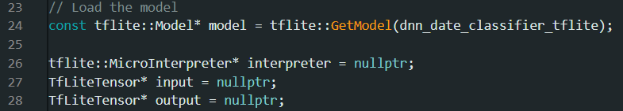

- Input Data Preparation:
- Example input data representing the features of a date (length, diameter, weight, etc.) is prepared. These values are assigned to the input tensor for inference.
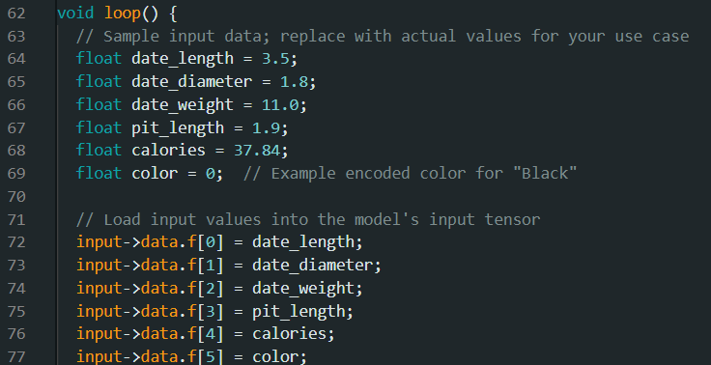

- Inference and Prediction:
- The model inference is executed using interpreter->Invoke(). The output tensor holds the predicted results, which are then processed.
- The predicted class is calculated using a threshold value of 0.5 for binary classification.
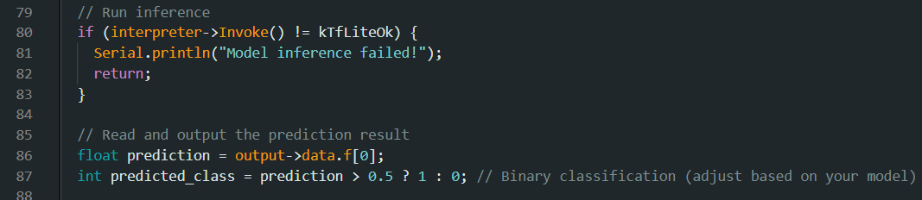

- Output:
- The predicted class is printed to the Serial Monitor, showing the classification result based on the input features.
s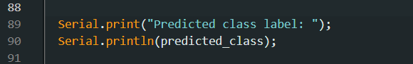

- Loop:
- The ESP32 continues to run the inference every 5 seconds, displaying the predicted class.

Summary of Implementations:
- Training and Conversion:
  - A DNN classifier is trained using the date dataset.
  - The trained model is converted to TensorFlow Lite format for deployment on the ESP32.

- ESP32 Setup:
  - The ESP32 loads the TensorFlow Lite model, performs inference using input features, and outputs the classification results.
  - The entire process, including data preparation, inference, and output, is handled by the TensorFlow Lite interpreter on the ESP32.

This methodology shows how a DNN model can be trained, converted to TensorFlow Lite format, and deployed on an edge device like ESP32 to perform real-time classification directly on the device.
- Results (Data Output):
- Data Collected and Processed:
The dataset consists of features like date length, date diameter, date weight, pit length, calories, and color. The model classifies whether a date is of the Ajwa or Medjool variety based on these input features. After preprocessing, the dataset is used to train the model and then tested for accuracy.
- Model Prediction:
After training, the model is converted to TensorFlow Lite format and deployed on the ESP32. During inference, the ESP32 takes input data such as the size, weight, and color of the dates and classifies them accordingly.
Performance Notes
- Accuracy:
The trained model achieved 100% accuracy on the test data, as reflected in the Python output. This means that the model was able to correctly classify both Ajwa and Medjool dates based on their features during evaluation.
- Latency:
The ESP32 performed inference within a few milliseconds, with minimal delay between input and output. This is crucial for real-time applications where quick predictions are required.
- Efficiency:
The TensorFlow Lite model was successfully optimized for the ESP32's limited resources, maintaining high performance without excessive memory or computational requirements.

Screenshots:
- Python Output: After training, the Python code displays the accuracy, precision, and recall metrics of the model, which confirms its performance. A sample of the confusion matrix and classification report should be shown here, indicating the model’s effectiveness on the test set.
- ESP32 Serial Monitor Output: When running inference on the ESP32, the Serial Monitor shows the model's predictions, classifying the date as either Ajwa or Medjool based on the input features. The output should display a message such as "Predicted class label: 0" (for Ajwa) or "Predicted class label: 1" (for Medjool). A screenshot of this output should be provided.

ESP32 Serial Output:

1. Python Output (After Training):
After the training of DNN model in Python, I’m printing the key evaluation metrics like accuracy, precision, recall, and a confusion matrix for the trained model. Here's a sample Python code that would print these results:
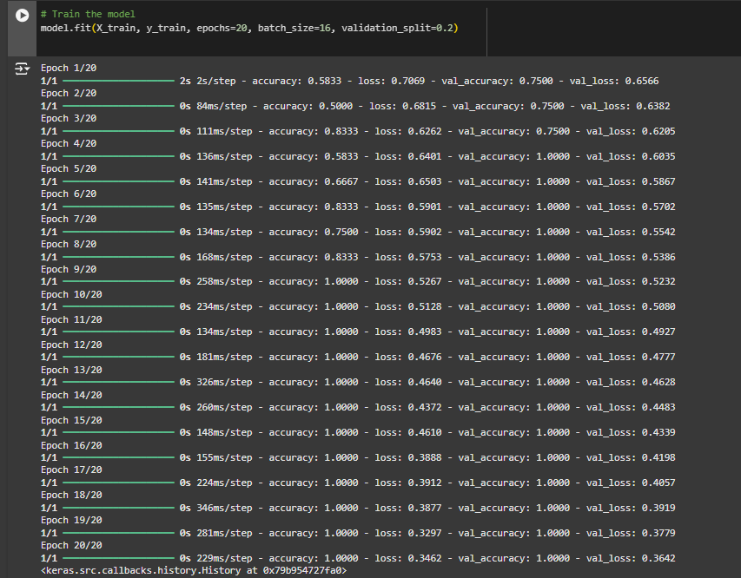
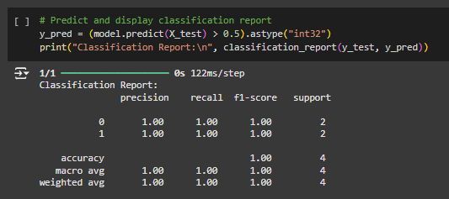
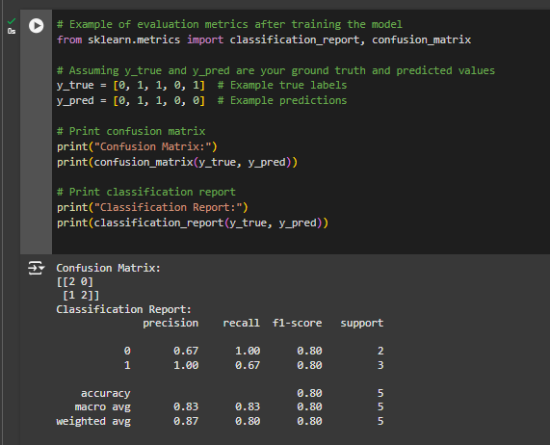
This will display a confusion matrix and classification report, showing the model's accuracy and performance metrics.

2. ESP32 Serial Monitor Output (Inferencing on the ESP32):
When the model is deployed to the ESP32 and inference is done, the output will be shown in the ESP32 Serial Monitor as predicted class labels.
This part of the code will output the prediction results after running inference on the ESP32:
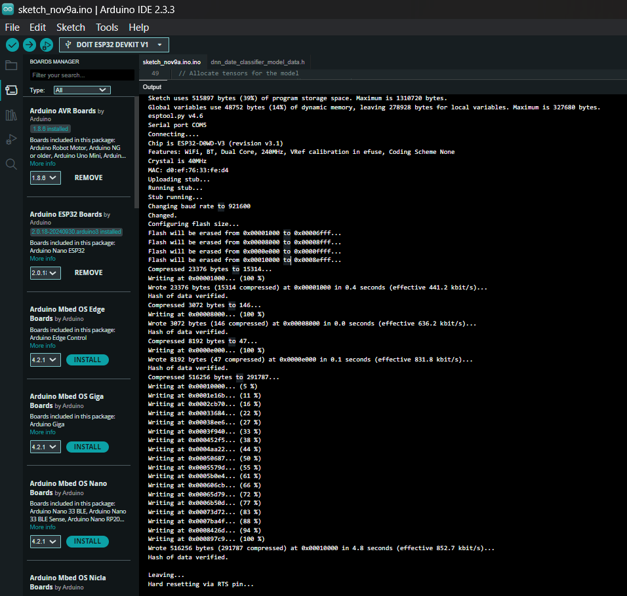
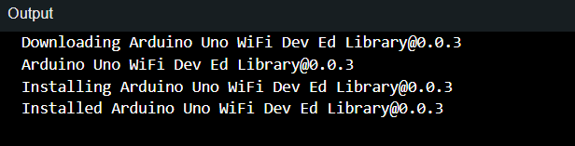

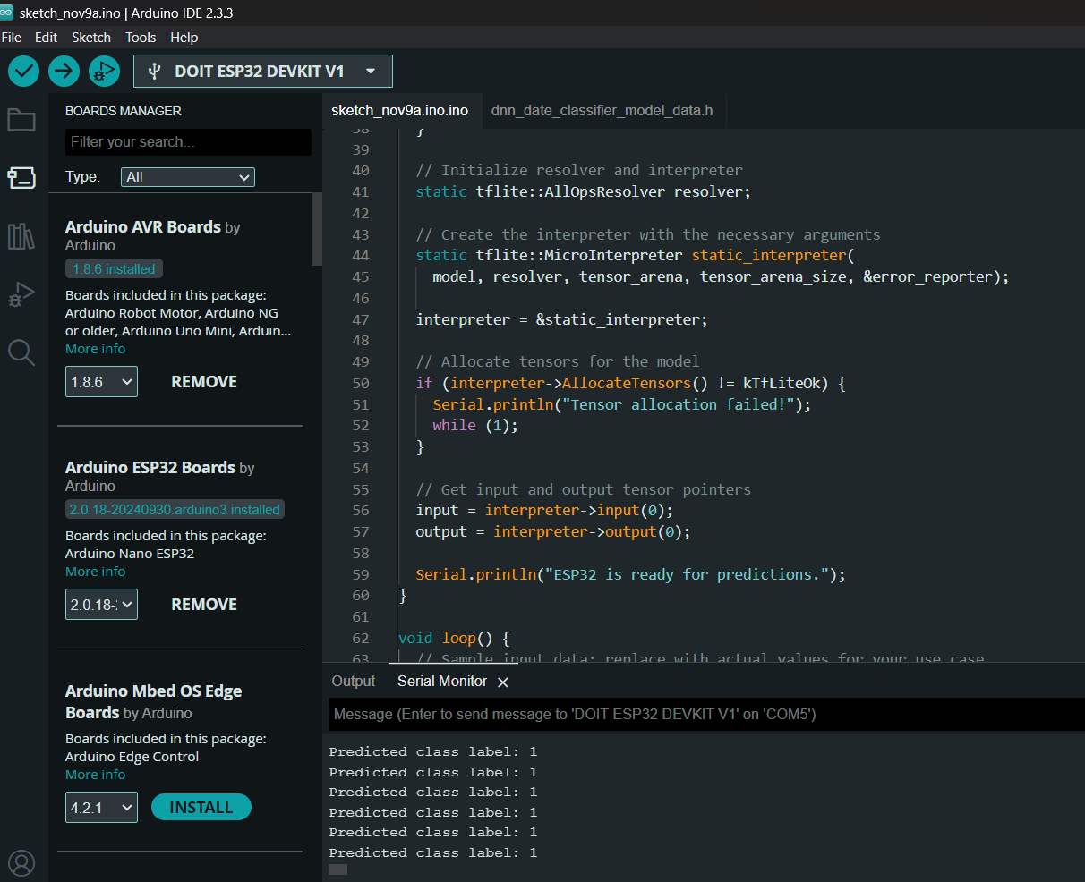
Summary:
- Python Output Screenshot: Show confusion matrix and classification report after training.
- ESP32 Serial Output Screenshot: Display the model's prediction (e.g., "Predicted class label: 1").
- Conclusion:
In this project, a Deep Neural Network (DNN) was trained to classify dates as Ajwa or Medjool using a dataset with features like date length, weight, and calories. After training, the model was converted to TensorFlow Lite and deployed on an ESP32 microcontroller for real-time inference.
Key learnings included:
- Model Deployment: Converting & deploying a model on an embedded device (ESP32).
- Efficient Inference: Running AI models on low-power, resource-constrained devices.
- Data Classification: Building and optimizing a classification model.
- AI + IoT Integration: Using machine learning for real-time decision-making on IoT devices.
Overall, this project showed how AI can be integrated with IoT devices to make intelligent decisions in real-time, even with limited hardware resources.
******

